Pancake Griddle w/20# LP
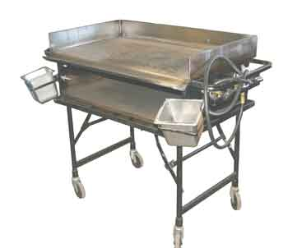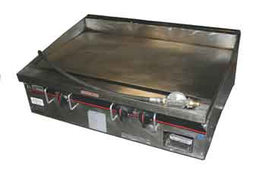
Operating Instructions

- Insure that all of the valves are closed.
- Attach the 20 lb propane tank to the griddle regulator.
- Open the valve on propane tank.
- Hold a lighted fireplace match or a fireplace lighter under the rear burner tube and slowly open the rear burner until the burner tube lights. It may take a few second for the gas line to be purged. Repeat this process for lighting each of the remaining two burners.
- Adjust the burners as need for proper griddle temperature.

Shutdown Instructions

- Close the burner valves from front to rear.
- Close the propane tank valve.
- Detach the propane tank from the griddle.

Cleaning Instructions

- Remove excess food stuff from griddle.
- Scour griddle with steel wool scouring pad or griddle scouring block.

Safety Precautions

- Use extreme caution in handling and using propane gas. Gas allowed to escape can result in a fire or explosion. It is heavier than air and may settle in the fire box or on the floor.
- Permit only competent persons to operate griddles.
- DO NOT leave the griddle unattended while operating.
- Check periodically to insure that all of the burners are ignited.
- If a burner goes out, shut off the gas valve immediately and allow the gas to dissipate for at least five (5) minutes before re-lighting.
- DO NOT use any adapters to connect different propane tanks and or other forms of gas to the griddle.
- DO NOT operate the griddle in a confined space without adequate ventilation. If air does not circulate, use a fan to exhaust air through window or other opening.

