LP Deep Fat Fryers
20#LP Table Top & 40# Floor Model
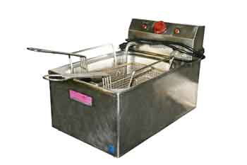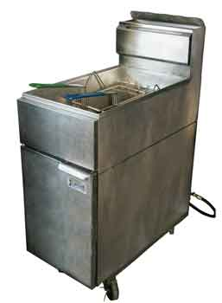
Operating Instructions
The following instructions will help recall the personal instructions given to you by your rental center.

- Insure that the gas control valve is turned off.
- Attach the 20 lb or 40 lb propane tank to the fryer regulator.
- Open the valve on propane tank.
- Turn the gas control valve knob to the pilot position. Push the control knob in and hold, use a match or a lighter to light the pilot (long fireplace matches or long fireplace lighters work best). Hold the control knob in for 30 to 60 second.
- After lighting the pilot let it burn for another 30 to 60 seconds before turning the control knob to on.
- Fill the fryer with the appropriate amount of frying oil.
- After filling the fryer and turning the control valve on, slowly turn the temperature control knob to the lowest setting. The main burners should turn on with in 3 to 5 seconds. After the main burners are on adjust the temperature to the desired temperature.

Shutdown Instructions

- Turn the safety valve to pilot.
- Close the propane tank valve.
- Turn the safety valve to off.
- Detach the propane tank from the fryer.

Cleaning Instructions

- Remove excess food stuff from fryer.
- Allow the oil to cool and drain the oil from the fryer.
- Clean with warm soapy water. Do not use steel wool or abrasive pads as they may degrade the metal finish.

Trouble Shooting
- If the pilot goes out after releasing the control valve wait 5 minutes and repeat the.
- If the main burners do not light, shut off the gas valve immediately and allow the gas to dissipate for at least five (5) minutes before re-lighting.
- If the main burner goes out, shut off the gas valve immediately and allow the gas to dissipate for at least five (5) minutes before re-lighting.

Safety Precautions

- Use extreme caution in handling and using propane gas. Gas allowed to escape can result in a fire or explosion. It is heavier than air and may settle in the fire box or on the floor.
- Permit only competent persons to operate fryer.
- DO NOT use the valve on the propane tank to control the gas flow to the fryer.
- DO NOT leave the fryer unattended while operating.
- Check periodically to insure that the main burner is ignited.
- DO NOT use any adapters to connect different propane tanks and or other forms of gas to the fryer.
- DO NOT operate the fryer in a confined space without adequate ventilation. If air does not circulate, use a fan to exhaust air through window or other opening.
- Use extreme caution when working with hot fryer oil. When placing food in the fryer the oil may splatter and could cause severe burns.

Deep Fryer | 100LB TANK PROPANE | Approx. 26 hours

Thank you for your rental!

