Popcorn Machine
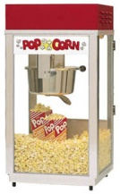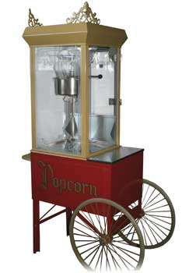
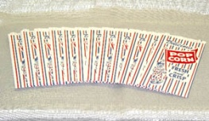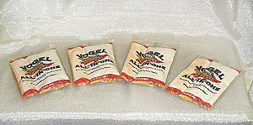
Dimensions: 20”w X 20”l x 38” h
Electrical: DO NOT use an extension cord or generator, machine may surge and burn up. Standard 120 volts, 60 cycle, single phase AC current.

Color: Red and Gold.
Transporting: Large vehicle or pickup truck, secure with rope. Heavy.
Add ons: Retail: popcorn/seasoning/oil, popcorn bags, popcorn boats, popcorn boxes

CONTROLS
There are three switches on this popper.
- LIGHT AND WARMER SWITCH – turns on heat lamp and optional strip heater under corn pan.
- KETTLE MOTOR SWITCH – turns on motor which drives kettle agitator shaft
- KETTLE HEAT SWITCH – turns on heat element inside kettle

CAUTION: The motor air intake and exhaust holes located on top of machine must be clear of any obstruction.
DO NOT COVER AIR VENT HOLES as serious damage may result.

TO AVOID SERIOUS BURNS, DO NOT TOUCH KETTLE WHILE IT IS HOT! ! !

TO START POPPING
- Turn “Kettle Heat” switch and Kettle Motor & Exhaust” switch ON.
- “Test Pop” a kettle of corn.
  - Place one fourth of the proper oil measure in the kettle along with three kernels of unpopped corn
  - As soon as the three kernels pop, place the balance of the oil, plus the measured amount of corn and “flavor” (if needed) in the kettle. Close lid.
- After the corn has finished popping, rotate the handle to dump the popcorn still in the kettle. Return the kettle to the upright position.
- Repeat the cycle starting with Item No 2 (eliminate the “Three Kernel Test Pop” step) and put a full charge of ingredients in at the same time to pop another kettle of corn. NOTE ALWAYS POP 4 to 5 BATCHES OF CORN IN A ROW. THE QUALITY AND FLAVOR ARE BOTH BETTER ON No. 2, 3, 4, and 5 THAN ON THE INITIAL BATCH.
- On the final kettle of corn, it is a good idea to turn the “Kettle Heat” and “Kettle Motor & Exhaust” switches off. Just as the lids are forced open by the popping corn. This saves electricity, since there is plenty of heat in the kettle, and also helps eliminate smoke and odor after you have stopped popping.
NEVER LEAVE THE HEAT ON WHEN YOU ARE NOT POPPING. If you place oil in a hot kettle, remember to finish that popping cycle, or turn off the kettle. Exposure to heat starts to break down color and flavor of popcorn oils.
Always wipe the complete exterior of your kettle with a heavy cloth immediately after you finish popping and the kettle has cooled. Oil drippings will come off quite easily at this time, but will burn on and stain if not removed.
- TURN ALL SWITCHES OFF at the close of your operations.

CLEANING INSTRUCTIONS
After you finish popping for the day, or your event, let the kettle cool until it is not too hot to handle, but still warm. Unplug kettle and remove it from machine. With cloth, wipe out the inside of kettle, the kettle lids, kettle crossbar, outside of kettle and underneath. DO NOT DUNK KETTLE IN WATER!!!

For fresh popcorn tomorrow: Always remove all the popped popcorn and pack it into clean plastic bags. Tie this tightly with a twister and you can enjoy fresh popcorn again tomorrow. Make sure the machine is sparkling clean when you return it and AVOID CLEANING CHARGES. Don’t forget to remove the old maid pan and empty out the unpopped kernels. Wipe clean.

If any problems occur during use, please call your professional party rental center. REMEMBER, you are renting this equipment. Be sure to understand your rental contract and be familiar with all charges for any damage or additional cleaning.

Complete your event by renting: Tables, chairs, linens, etc.
Don’t forget to purchase enough popcorn supplies to last for your event.

