 | SnoKone Machine  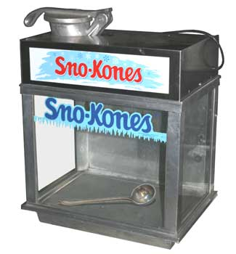
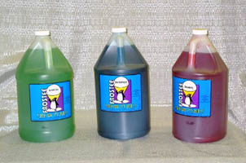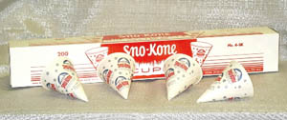
Dimensions: 16”w X 25”l X 31”h
Electrical: Do not run on long extension cord or generator, machine may surge and burn up. 110 volt, single phase, 60 cycle AC current.
Transporting: Heavy! Fits in back seat/ trunk of most cars.
Misc: pumps for syrup “rent” for free. 10# of ice makes about 50 cones, gallon of syrup makes about 160-230 cones. (be sure to return the PUMPS and ICE SCOOP with the machine!)
Add ons: Sno Cone Syrup & cups

The Sno-Kone Machine is a great attraction for Birthday Parties, School Functions and more! It is a very simple machine to operate, but in order to get the best results, please read the following BEFORE you attempt to operate the machine.

IMPORTANT INFORMATION
The Sno-Kone Machine consists of the motor, shaving unit, and dispensing case. The motor has a toggle switch mounted on it. There is a separate switch on the light inside the case.
On the end of the motor shaft is mounted the cutterhead which is inside of the shaver body (gooseneck). Going down into the shaver body is the pusher handle which presses the ice against the revolving cutterhead which shaves the ice. CAUTION: Machine must be properly grounded to prevent shock in case of electrical problems. The motor is 110 volt single phase, 60 cycle, AC current.

TO OPERATE MACHINE
- Start the motor and fill the gooseneck with ice cubes or block ice broken into pieces 3” to 4” in size. Fill to about an inch or so from the top, the larger the piece of ice the better the snow.
- Push the pusher handle down to press the ice against the cutterhead. A firm even pressure is all that is required, but sometimes you will find it better to relieve the pressure two or three times on the way down. This lets the ice rearrange itself and you get a better bite.
- DO NOT FORCE THE HANDLE too much as the motor could be stalled.
- When too much pressure is necessary, relieve the handle, and then come down again. Too much pressure on the pusher handle will make the ice come out coarse; too little makes the ice mushy.

IN NORMAL OERATIONS THE MOTOR GETS WARM – A SURFACE TEMPURATURE OF 150º IS NORMAL.

CAUTION: DO NOT LET ANY METAL GET DOWN IN THE GOOSENECK, OR YOU WILL RUIN THE BLADES.
Never put your fingers or any object into the shaver body while motor is running. Disregard for these instructions and careless handling will result in accidents or injury. If problems not covered occur, contact your professional party rental center immediately.

CLEANING: Always unplug the machine before cleaning. Wipe all surfaces clean before returning to the rental center and AVOID ADDITIONAL CLEANING CHARGES. The ICE SCOOP and SYRUP PUMPS are considered RENTALS and MUST BE RETURNED with the machine or a replacement charge will incur.

